February 29- March 4
HOMEWORK
Sight Words:
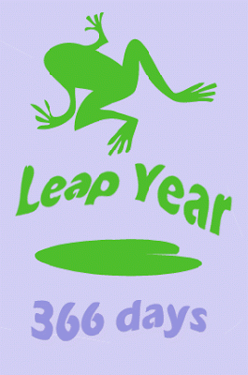
Monday February 29, 2016

*LEAP DAY!*

- Reading:
- Spelling: Study for Spelling Test on Friday!!
- Math: worksheet

Tuesday March 1, 2016

1. Reading: Read your library book.
2. Spelling: Study for Spelling Test on Friday!!
3. Math: worksheet

Wednesday March 2, 2016

*DR. SEUSS’S BIRTHDAY*

1. Reading: Read Scholastic News “The True Story of Green Eggs and Ham” and complete activities.
2. Spelling: Study for Spelling Test on Friday!!
3. Math: worksheet

Thursday March 3, 2016

- Reading: Read “Winter Fun” and answer questions.

- Spelling: Study for Spelling Test TOMORROW!!
- Math: worksheet

Friday March 4, 2016

PLEASE SIGN AND RETURN YOUR CHILD’S FRIDAY FOLDER, BEHAVIOR CHART, AND BUSY FEET LETTERON TUESDAY, MARCH 8th!

